In order to begin CN clearance in PAMS, Program Officers must log in to PAMS and create a CN. This is different from creating a proposal, and can only take place after the proposal is approved by the Program Officer.

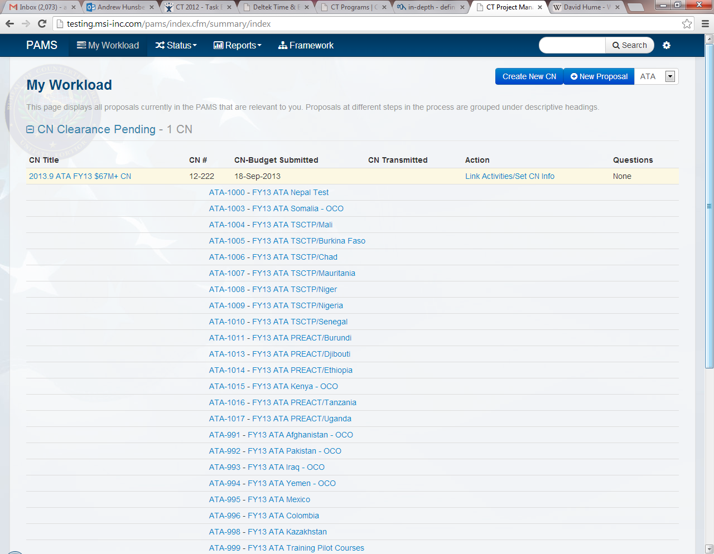Program Officers will log in to PAMS, access their Workload Summary, and select **“Create CN”**.

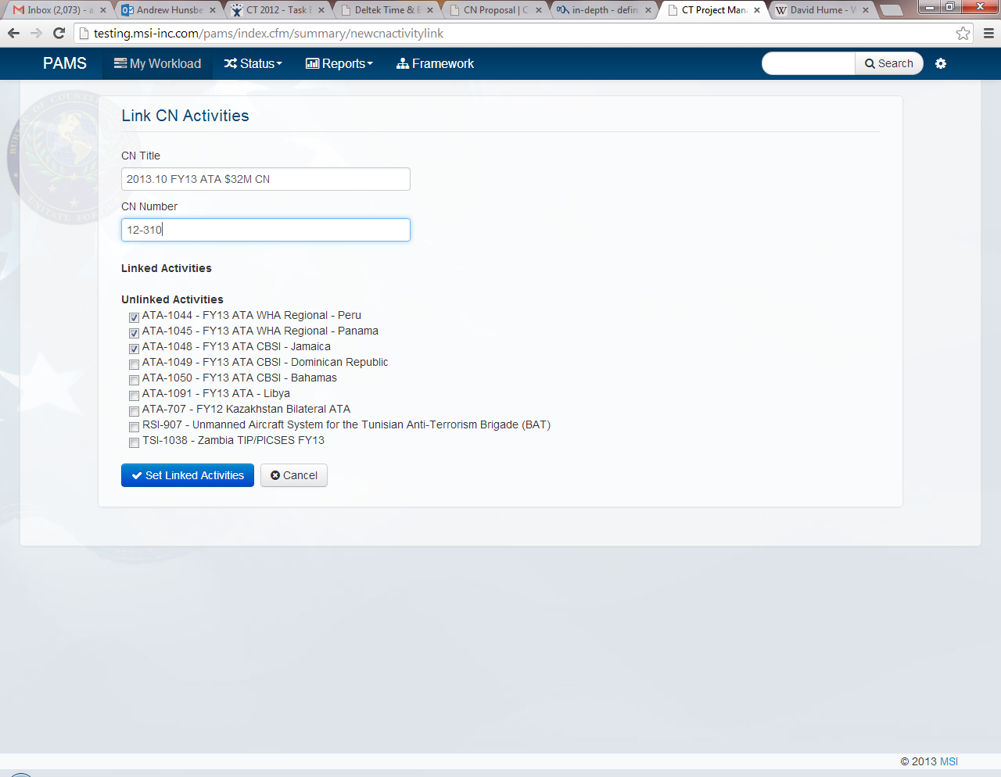Program Officers will enter a **CN title** and a **CN number** (if available) and **select the projects to be linked** in the CN.

Once the CN information has been entered and the relevant projects have been linked, Program Officers will select “**Set Linked Activities”** to create a CN.

Program Officers will now be able to access their newly created CN on their Workload under **“CN Clearance Pending”**.

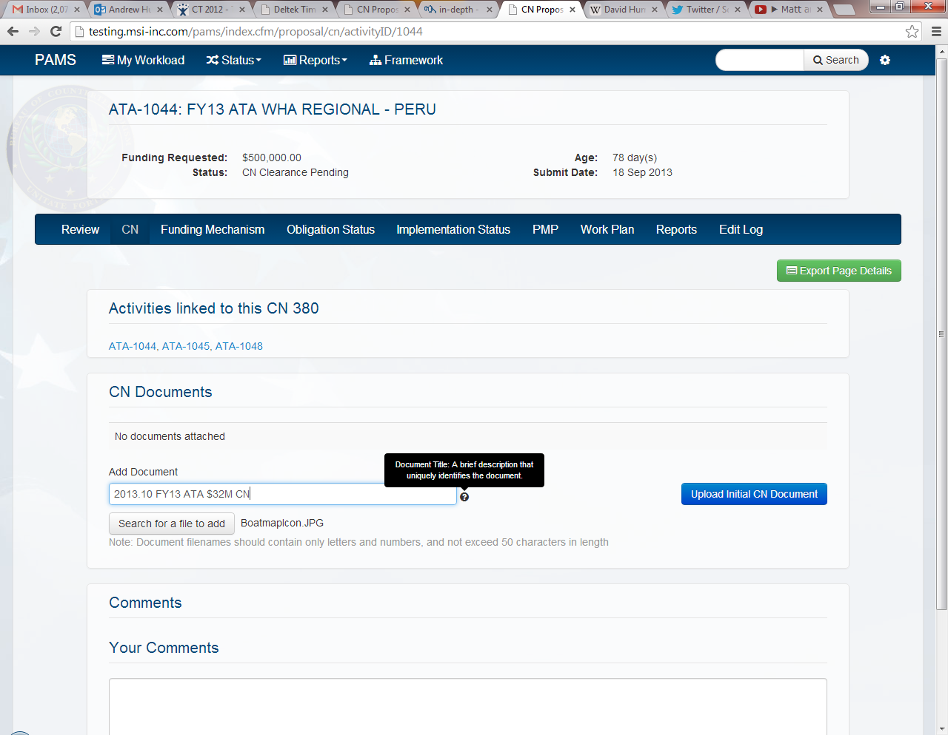In order to submit the CN to Budget, Program Officers will open their newly created CN, open the CN tab, upload a CN document, and enter a document title. The CN has not been officially submitted until this step occurs.

Once a document has been uploaded and titled, Program Officers will select **“Upload Initial CN Document”** to complete the submission process. *Budget will automatically be notified via email that the project in question is ready for CN clearance*

**\*\*\*NOTE**: CN document file names should contain simple characters and **no commas**.CN document file names with commas will not open in Google Chrome.